4-H’ERS COMPETE IN ARCHERY COMPETITION
Five members of the Rains 4-H Club participated in the District 4-H Archery Competition in Texarkana, Texas on Saturday, May 1st. This is the second year that our kids participated in this event, and they had a blast and represented Rains 4-H well. We were not able to attend last year due to cancellation from Covid. It was great to get these kids back out on the range.

Rains 4-H had over fifteen youth participating in the Archery Project. For ten weeks, kids learned many aspects related to this project. Archers learned many safety precautions and shooting scenarios to help them prepare. They also learned different parts of the bow so they could make sure that it is functioning properly and safely.

The 4-H members that attended the District Archery Contest have participated in the project for the past four years. They have worked very hard to hone and improve their shooting skills over the years.

I would like to thank Mr. Jeremy Cook for taking the time to help train these 4-H members. His time and dedication are greatly appreciated. I would also like to thank all the 4-H members and parents that attended the competition.

Following are the results of this competition:

Junior Division
Hunter Tapp 1st Place
Landon William 3rd Place
Major Wallace 6th Place

Intermediate Division

Gunner Cook 1st Place
Gage Cook 3rd Place

Next year not only will we be competing in the archery contest, but we have also started a 4-H Shotgun Project. These kids are also learning many safety aspects in the are areas of trap and skeet.

Congratulations to all for a job well done!

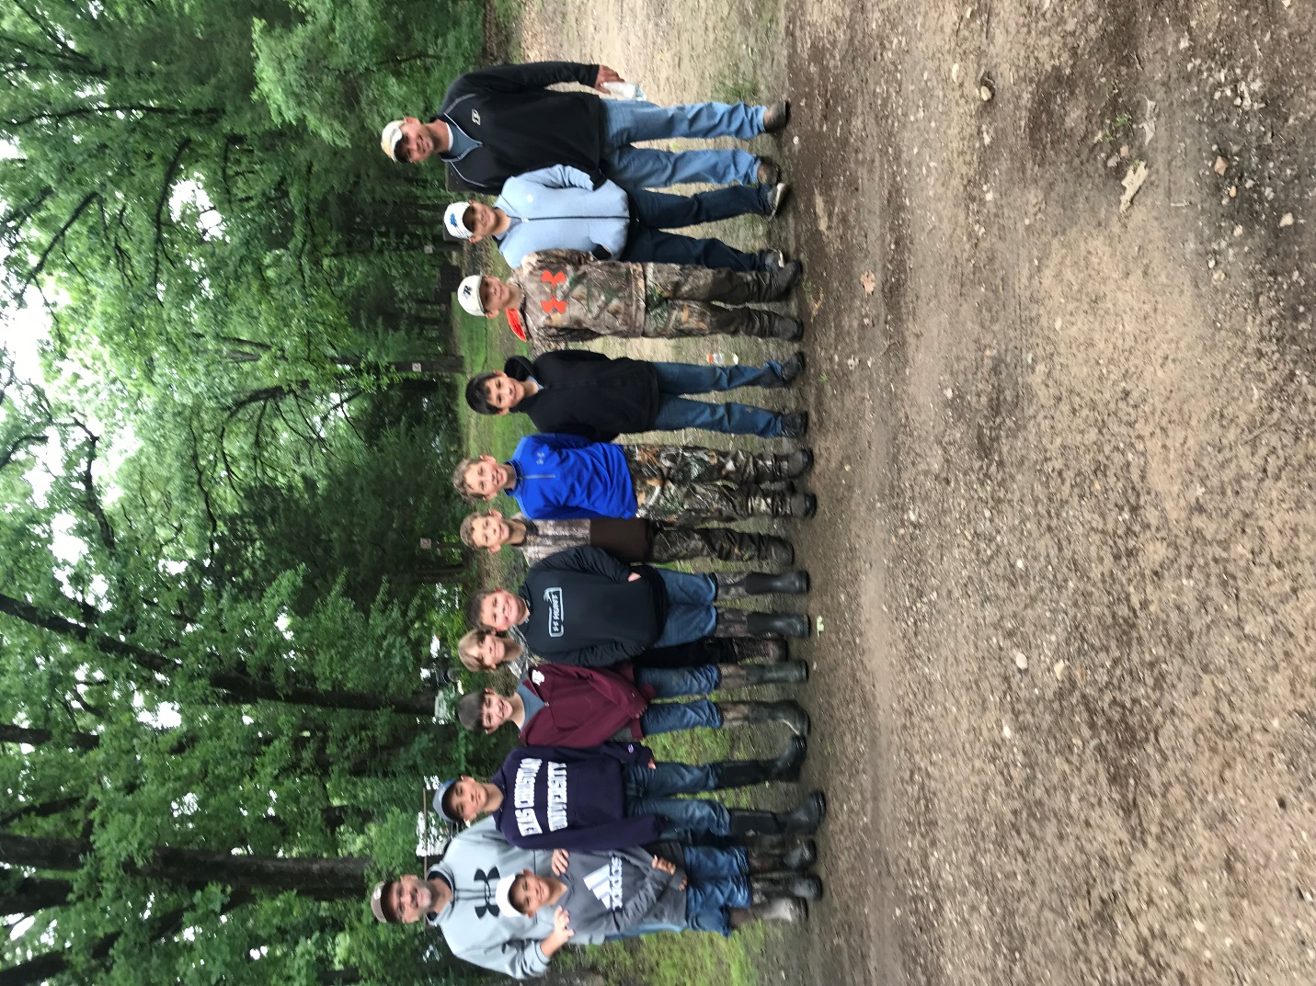

Pictured left to right: County Agent, Stephen Gowin, Major Wallace, Jaxon Wallace, Hagen Gowin, Gavin Pierce, John Michael McAllister, Gunner Cook, Wyatt Cook, Jason Wilson, Gage Cook, Justin Wilson, and Coach Jeremy Cook

